CSA0517 DBMS LAB

- Create Employee table for the following details

S.No | Name | Designation | Branch
1 | Suresh | Manager | Chennai
2 | Ramesh | Supervisor | Madurai
3 | Hari | Assistant | Trichy

Perform the following:
- Alter the table by adding a column Salary
- Alter the table by modifying the column Name
- Describe the table employee
- Rename table employee as emp
- Delete the Second row from the table
- Drop the table
- Create a Table as bank and the details are
S.No | Cust_Name | Acc_no | Balance | Cus_Branch
1 | Ramesh | 12378 | 100000 | Adyar
2 | Sam | 12367 | 152500 | Mylapore
3 | Harish | 12345 | 250000 | Anna Salai

Perform the following:
- Simple Select
- Select with where clause
- Select with comparison operator >
- Select withbetween in the field Balance
- Update the Cus_Branch in the second row as Poonamallee

- Create a Table as book and the details are
S.No | B_Name | Author | Price | Publisher
1 | DBMS | Seema Kedhar | 250 | Charulatha
2 | TOC | John Martin | 400 | Tata McGraw Hill
3 | C | Balagurusamy | 300 | Technical
Perform the following:
  - Use Select keyword and display the table
  - Display the book which is => 300
  - Insert a row and add new book to the book table
  - Drop Author column
- Create a Table as workers and the details are

S.No | Name | Designation | Branch
1 | Kannan | Manager | Chennai
2 | Mahesh | Supervisor | Madurai
3 | Maruthi | Assistant | Trichy
Perform the following:
  - Alter the table by adding a column Salary
  - Alter the table by modifying the column Name
  - Describe the table employee
  - Copy the table employee as emp
  - Delete the Second row from the table
  - Drop the table

- Create a Table as Student and the details are
S.No | Name | Subject | Mark
1 | Somu | OS | 75
2 | Sankar | DBMS | 66
3 | Mahesh | MOBILE COMPUTING | 92

Perform the following:
  - Alter the table by adding a column Grade
  - Alter the table by modifying the column Name
  - Describe the table Subject
  - Copy the table Subject as sub
  - Delete the Second row from the table
  - Drop the table

- Write the DDL Commands for the following,
A. Create a table name STUDENT with following structure.
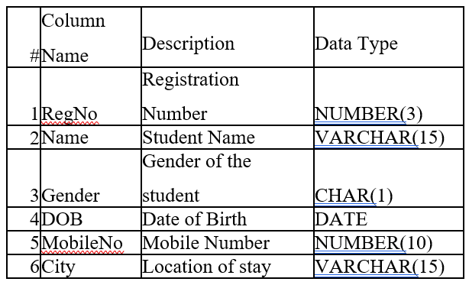

B. Create a table name FACULTY with following structure.

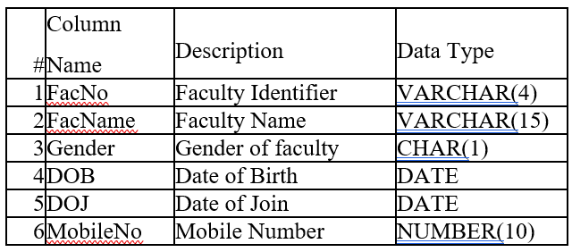

C. Create a table name DEPARTMENT with following structure.
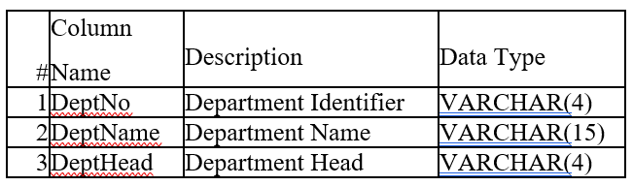

- Write the SQL Queries SELECT with ORDER BY for the following,
- Retrieve Name, Gender, MobileNo of all the students in ascending order of RegNo.
- List the faculty members in the order of older faculty first.
- How many students are registered for each course? Display the course description and the number of students registered in each course.

- Write the SQL Queries for TCL commands Commit, Rollback and Savepoint to the following,
- Rollback to that state using the ROLLBACK command whenever required.
- Create a following table Class and insert values into it in the order and create savepoints in between them.
- Try to rollback t the save point and check your output by giving select commands.

- Write the SQL Queries SubQuery for the following,
- Which of the student’s score is greater than the highest score?
- Which of the students’ have written more than one assessment test?
- Which faculty has joined recently and when?

